Syed Sualeh abbas, Syed Zaid Naqvi, Mohsin Mujtaba

Lab 8: Design and FPGA Implementation of Memory System with Address Decoding for a Single-Cycle RISC-V Processor

Task 1: Design of Data Memory and Address Decoder

Block diagram of memory system with address decoding.

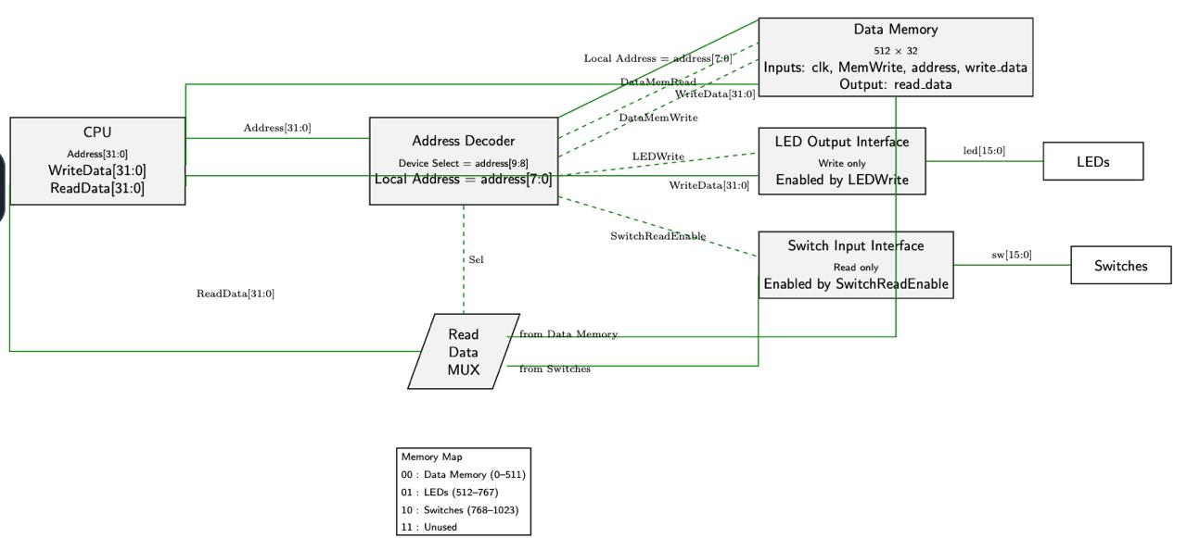

Task 2: Verilog Implementation and Testbench Development

Verilog source file for Data Memory

module DataMemory (

input clk,

input MemWrite, // Write enable (synchronous)

input MemRead, // Read enable (asynchronous)

input [8:0] address, // 9-bit local address → 512 locations

input [31:0] write_data,

output reg [31:0] read_data

);

// 512-word × 32-bit memory array

reg [31:0] memory [0:511];

// Initialise all locations to 0 (helps simulation)

integer i;

initial begin

for (i = 0; i < 512; i = i + 1)

memory[i] = 32'b0;

end

// Synchronous write

always @(posedge clk) begin

if (MemWrite)

memory[address] <= write_data;

end

// Asynchronous (combinational) read

always @(*) begin

if (MemRead)

read_data = memory[address];

else

read_data = 32'b0;

end

endmodule

Verilog source file for Address Decoder

module AddressDecoder (

input [31:0] address,

input readEnable,

input writeEnable,

output reg DataMemWrite,

output reg DataMemRead,

output reg LEDWrite,

output reg SwitchReadEnable

);

// Only the top 2 bits of the 10-bit local address determine the device

wire [1:0] deviceSelect;

assign deviceSelect = address[9:8];

always @(*) begin

// Safe defaults - only one device active at a time

DataMemWrite = 1'b0;

DataMemRead = 1'b0;

LEDWrite = 1'b0;

SwitchReadEnable = 1'b0;

case (deviceSelect)

2'b00: begin // Data Memory (0-511)

DataMemWrite = writeEnable;

DataMemRead = readEnable;

end

2'b01: begin // LEDs (512-767) - write only

LEDWrite = writeEnable;

end

2'b10: begin // Switches (768-1023) - read only

SwitchReadEnable = readEnable;

end

default: begin // 2'b11 - no device selected

DataMemWrite = 1'b0;

DataMemRead = 1'b0;

LEDWrite = 1'b0;

SwitchReadEnable = 1'b0;

end

endcase

end

endmodule

Testbench

module MemorySystem_tb;

// ----------------------------------------------------------------

// DUT ports

// ----------------------------------------------------------------

reg clk, rst;

reg [31:0] address;

reg readEnable, writeEnable;

reg [31:0] writeData;

reg [15:0] switches;

wire [31:0] readData;

wire [15:0] leds;

// ----------------------------------------------------------------

// Hierarchical probes - visible in the waveform viewer

// ----------------------------------------------------------------

wire DataMemWrite = DUT.decoder.DataMemWrite;

wire DataMemRead = DUT.decoder.DataMemRead;

wire LEDWrite = DUT.decoder.LEDWrite;

wire SwitchReadEnable = DUT.decoder.SwitchReadEnable;

// ----------------------------------------------------------------

// DUT instantiation

// ----------------------------------------------------------------

addressDecoderTop DUT (

.clk (clk),

.rst (rst),

.address (address),

.readEnable (readEnable),

.writeEnable(writeEnable),

.writeData (writeData),

.switches (switches),

.readData (readData),

.leds (leds)

);

// ----------------------------------------------------------------

// Clock: 10 ns period (100 MHz)

// ----------------------------------------------------------------

initial clk = 0;

always #5 clk = ~clk;

// ----------------------------------------------------------------

// Pass / Fail counters

// ----------------------------------------------------------------

integer pass_cnt = 0;

integer fail_cnt = 0;

// ----------------------------------------------------------------

// TASK: check - compare expected vs actual and print result

// ----------------------------------------------------------------

task check;

input [159:0] label;

input [31:0] expected;

input [31:0] actual;

begin

if (expected === actual) begin

$display(" PASS %-22s exp=%h got=%h",

label, expected, actual);

pass_cnt = pass_cnt + 1;

end else begin

$display(" FAIL %-22s exp=%h got=%h <---",

label, expected, actual);

fail_cnt = fail_cnt + 1;

end

end

endtask

// ----------------------------------------------------------------

// TASK: do_write - synchronous write (one clock cycle)

// Drives on negedge so inputs are stable before posedge capture.

// ----------------------------------------------------------------

task do_write;

input [31:0] addr;

input [31:0] data;

begin

@(negedge clk);

address = addr;

writeData = data;

writeEnable = 1'b1;

readEnable = 1'b0;

@(posedge clk); #1; // data captured on this rising edge

writeEnable = 1'b0;

end

endtask

// ----------------------------------------------------------------

// TASK: do_read - combinational read

// Asserts readEnable, waits 2 ns for combinational settle,

// caller samples signals, then deasserts after next posedge.

// ----------------------------------------------------------------

task do_read;

input [31:0] addr;

begin

@(negedge clk);

address = addr;

readEnable = 1'b1;

writeEnable = 1'b0;

#2; // combinational paths settle (well within half-period)

// *** caller checks readData and decoder signals HERE ***

@(posedge clk); #1;

readEnable = 1'b0;

end

endtask

// ================================================================

// STIMULUS

// ================================================================

initial begin

$display("====================================================");

$display(" MemorySystem Testbench - Lab 8");

$display("====================================================");

// ---------- Reset ----------

rst = 1'b1;

address = 32'd0;

readEnable = 1'b0;

writeEnable = 1'b0;

writeData = 32'd0;

switches = 16'd0;

repeat (4) @(posedge clk);

@(negedge clk);

rst = 1'b0;

// ============================================================

// 1. DATA MEMORY - address[9:8] = 2'b00 (addresses 0-255)

// ============================================================

$display("\n[1] Data Memory - Writes");

do_write(32'd0, 32'hAAAA_BBBB);

do_write(32'd1, 32'h1234_5678);

do_write(32'd10, 32'hDEAD_BEEF);

do_write(32'd200, 32'hCAFE_F00D);

do_write(32'd255, 32'h0000_FFFF); // last address in DataMem range

$display("\n[2] Data Memory - Read-Back");

do_read(32'd0);

check("DM[0]=AAAABBBB", 32'hAAAA_BBBB, readData);

check("DataMemRead hi", 32'd1, DataMemRead);

check("DataMemWrite lo", 32'd0, DataMemWrite);

check("LEDWrite lo", 32'd0, LEDWrite);

check("SwitchRdEn lo", 32'd0, SwitchReadEnable);

do_read(32'd1);

check("DM[1]=12345678", 32'h1234_5678, readData);

do_read(32'd10);

check("DM[10]=DEADBEEF", 32'hDEAD_BEEF, readData);

do_read(32'd200);

check("DM[200]=CAFEF00D", 32'hCAFE_F00D, readData);

do_read(32'd255);

check("DM[255]=0000FFFF", 32'h0000_FFFF, readData);

// ============================================================

// 2. LED CONTROLLER - address[9:8] = 2'b01 (addresses 256-511)

// ============================================================

$display("\n[3] LED Controller - Writes");

do_write(32'd256, 32'h0000_A5A5); // first LED address

@(posedge clk); #1; // extra cycle: led_reg latches

check("LEDs=A5A5", 32'h0000_A5A5, {16'b0, leds});

do_write(32'd300, 32'h0000_5A5A);

@(posedge clk); #1;

check("LEDs=5A5A", 32'h0000_5A5A, {16'b0, leds});

do_write(32'd511, 32'h0000_1234); // last LED address

@(posedge clk); #1;

check("LEDs=1234", 32'h0000_1234, {16'b0, leds});

// Verify decoder exclusivity during an LED write

@(negedge clk);

address = 32'd400; // LED range

writeEnable = 1'b1;

readEnable = 1'b0;

#2;

check("LED: LW=1", 32'd1, LEDWrite);

check("LED: DmW=0", 32'd0, DataMemWrite);

check("LED: DmR=0", 32'd0, DataMemRead);

check("LED: SRE=0", 32'd0, SwitchReadEnable);

@(posedge clk); #1;

writeEnable = 1'b0;

// ============================================================

// 3. SWITCH INTERFACE - address[9:8] = 2'b10 (addresses 512-767)

// ============================================================

$display("\n[4] Switch Interface - Reads");

switches = 16'hF0F0;

do_read(32'd512); // first Switch address → [9:8]=10

check("SW[512]=F0F0", 32'h0000_F0F0, readData);

check("SwitchRdEn hi", 32'd1, SwitchReadEnable);

check("SW: DmR=0", 32'd0, DataMemRead);

check("SW: DmW=0", 32'd0, DataMemWrite);

check("SW: LW =0", 32'd0, LEDWrite);

switches = 16'h0F0F;

do_read(32'd600); // mid Switch range

check("SW[600]=0F0F", 32'h0000_0F0F, readData);

check("SRE hi (600)", 32'd1, SwitchReadEnable);

switches = 16'hAAAA;

do_read(32'd767); // last Switch address

check("SW[767]=AAAA", 32'h0000_AAAA, readData);

check("SRE hi (767)", 32'd1, SwitchReadEnable);

switches = 16'h5555;

do_read(32'd512);

check("SW[512]=5555", 32'h0000_5555, readData);

switches = 16'hFFFF;

do_read(32'd700);

check("SW[700]=FFFF", 32'h0000_FFFF, readData);

// ============================================================

// 4. UNUSED RANGE - address[9:8] = 2'b11 (addresses 768-1023)

// All decode outputs must remain low.

// ============================================================

$display("\n[5] Unused Address Range");

@(negedge clk);

address = 32'd768; // [9:8]=11 → no device

readEnable = 1'b1;

writeEnable = 1'b0;

#2;

check("Unused: SRE=0", 32'd0, SwitchReadEnable);

check("Unused: DmR=0", 32'd0, DataMemRead);

check("Unused: LW =0", 32'd0, LEDWrite);

check("Unused: DmW=0", 32'd0, DataMemWrite);

check("Unused: rDat=0",32'd0, readData);

@(posedge clk); #1;

readEnable = 1'b0;

@(negedge clk);

address = 32'd1023; // [9:8]=11 → no device

writeEnable = 1'b1;

readEnable = 1'b0;

#2;

check("Unused1023:DmW=0",32'd0, DataMemWrite);

check("Unused1023:LW =0",32'd0, LEDWrite);

@(posedge clk); #1;

writeEnable = 1'b0;

// ============================================================

// 5. DECODER EXCLUSIVITY - no enables overlap for any device

// ============================================================

$display("\n[6] Decoder Exclusivity Sweep");

// DataMem write

@(negedge clk); address=32'd128; writeEnable=1; readEnable=0; #2;

check("Excl DmW=1", 32'd1, DataMemWrite);

check("Excl DmR=0", 32'd0, DataMemRead);

check("Excl LW =0", 32'd0, LEDWrite);

check("Excl SRE=0", 32'd0, SwitchReadEnable);

@(posedge clk); #1; writeEnable=0;

// DataMem read

@(negedge clk); address=32'd128; readEnable=1; writeEnable=0; #2;

check("Excl DmR=1", 32'd1, DataMemRead);

check("Excl DmW=0", 32'd0, DataMemWrite);

check("Excl LW =0", 32'd0, LEDWrite);

check("Excl SRE=0", 32'd0, SwitchReadEnable);

@(posedge clk); #1; readEnable=0;

// LED write

@(negedge clk); address=32'd350; writeEnable=1; readEnable=0; #2;

check("Excl LW =1", 32'd1, LEDWrite);

check("Excl DmW=0", 32'd0, DataMemWrite);

check("Excl DmR=0", 32'd0, DataMemRead);

check("Excl SRE=0", 32'd0, SwitchReadEnable);

@(posedge clk); #1; writeEnable=0;

// Switch read

@(negedge clk); address=32'd650; readEnable=1; writeEnable=0; #2;

check("Excl SRE=1", 32'd1, SwitchReadEnable);

check("Excl DmW=0", 32'd0, DataMemWrite);

check("Excl DmR=0", 32'd0, DataMemRead);

check("Excl LW =0", 32'd0, LEDWrite);

@(posedge clk); #1; readEnable=0;

// ============================================================

// Summary

// ============================================================

repeat(4) @(posedge clk);

$display("\n====================================================");

$display(" TOTAL: PASS = %0d FAIL = %0d", pass_cnt, fail_cnt);

if (fail_cnt == 0)

$display(" *** All tests passed! ***");

else

$display(" *** %0d test(s) FAILED - review above ***", fail_cnt);

$display("====================================================\n");

$stop;

end

endmodule

Simulation waveforms showing correct operation\

DATA MEMORY SECTION:
DATA MEMORY WRITE (40ns-100ns):
DATA MEMORY READ (100ns- 140ns)

Waveform explanations:
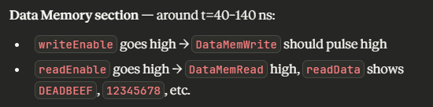

AT 100ns, all the values that were stored; will start showing at READ DATA. Where the yellow marker is places
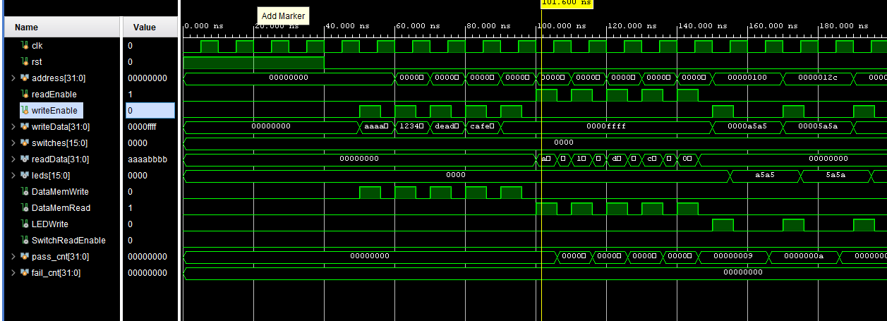

LED SECTION:
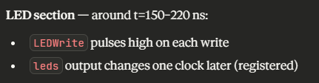

As WRITE DATA has some value, so when led write rises, the value is shown on leds. After it falls back. As seen in the wave forms. When first ledwrite falls at 160ns, the led output can be seen same as writedata.
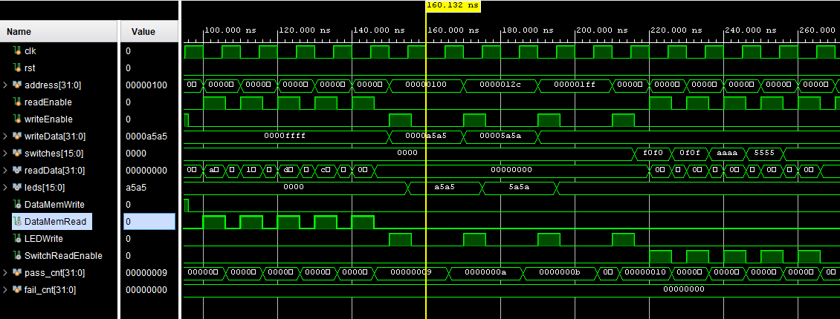

Same goes here
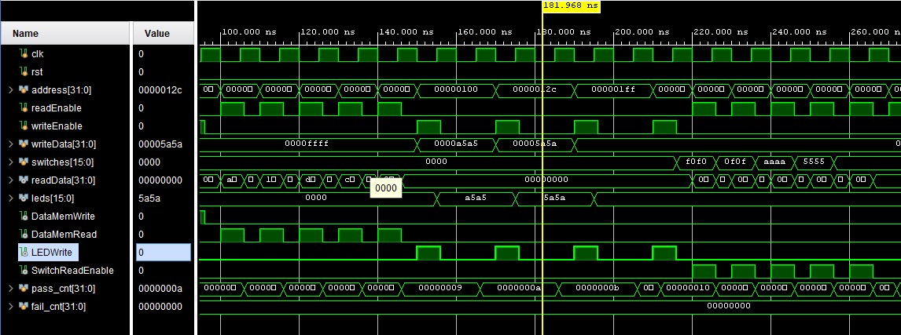

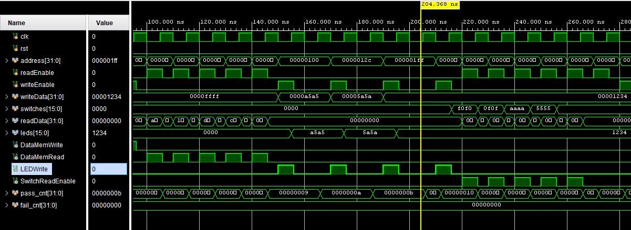

SWITCH SECTION:
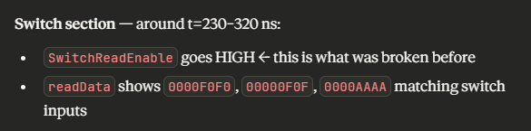

As we put input in swiches, then when the READDATA turns 1, it basically replicates the value of switches, as can be seen in wave forms.

As here in this wave form we can see that switch read enable was zero. Readdata, did not get the value which was in switches.
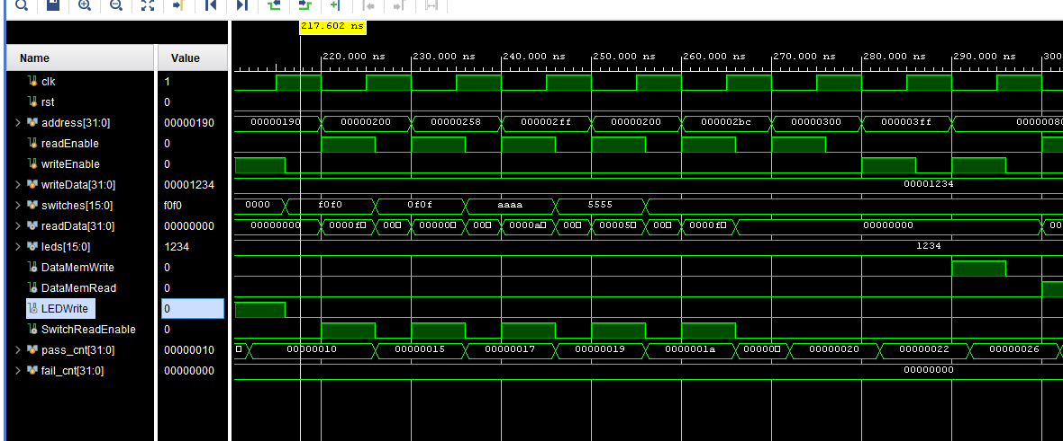

Now when the switchreadenable becomes 1. It reads the value of switches as can be seen in the following waveforms.
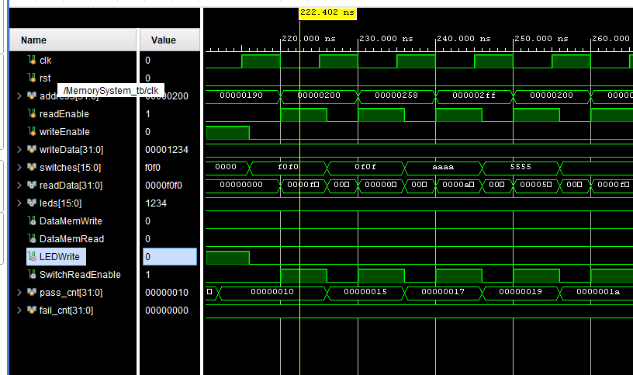

Rest is also the same way
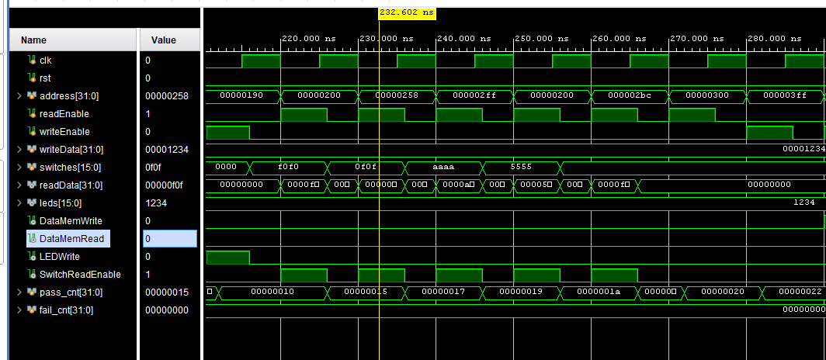

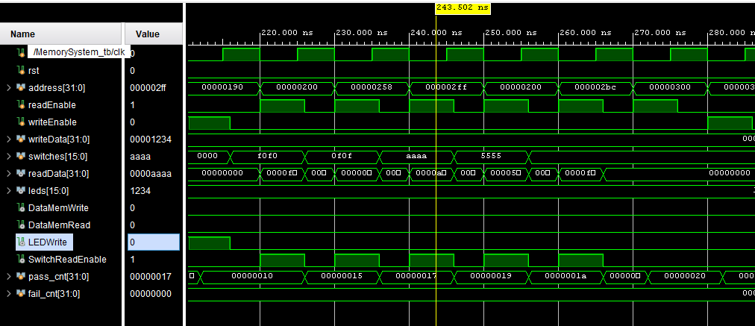

Picture of full waveform of test bench

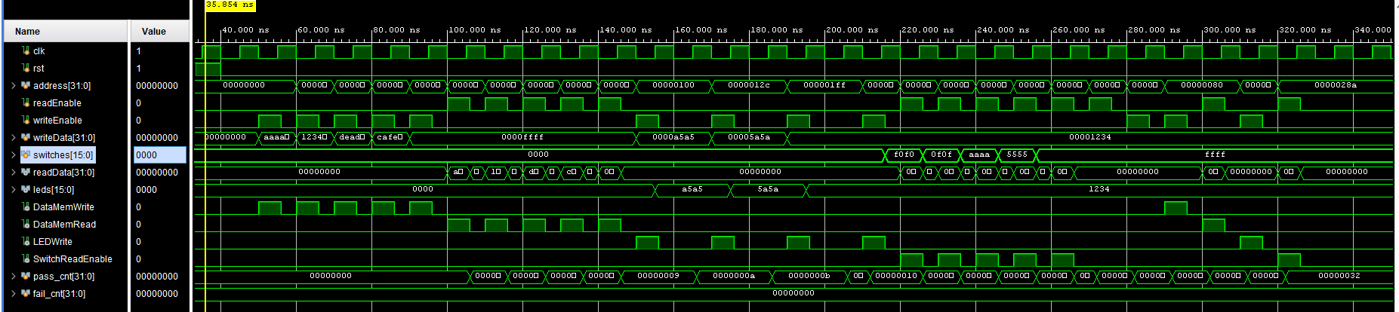

Task 3: FPGA Synthesis and RTL Analysis

RTL schematic screenshots (register file array, decoder, FSM, ALU connections)

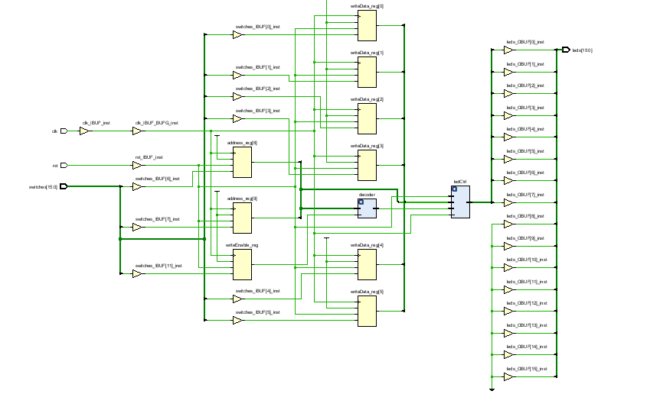

Demonstration of FPGA operation

SW0 → writeData bit0 → LD0

SW1 → writeData bit1 → LD1

SW2 → writeData bit2 → LD2

SW3 → writeData bit3 → LD3

SW4 → writeData bit4 → LD4

SW5 → writeData bit5 → LD5

SW6 → writeData bit6 → LD6

SW7 → writeData bit7 → LD7

SW8 → address[8] (device select LSB)

SW9 → address[9] (device select MSB)

SW10 → readEnable

SW11 → writeEnable

SW12 → unused

SW13 → unused

SW14 → unused

SW15 → unused

Write data
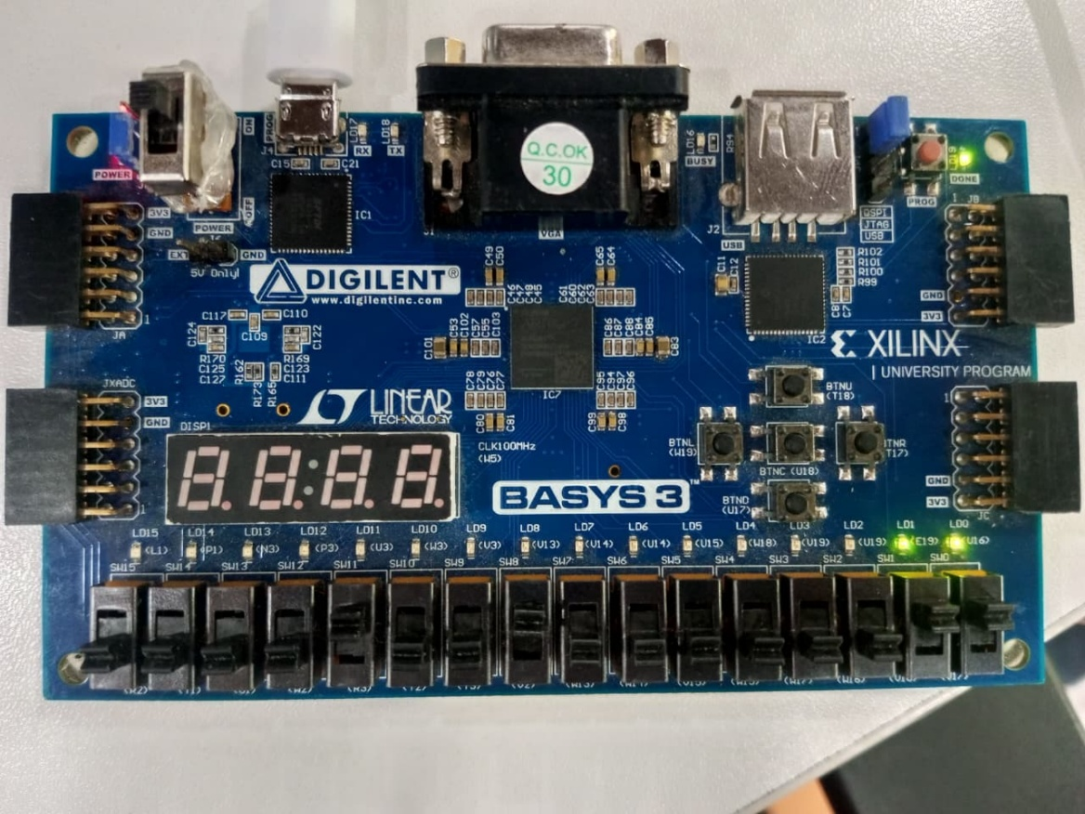

Read data from switches. No led will turn on
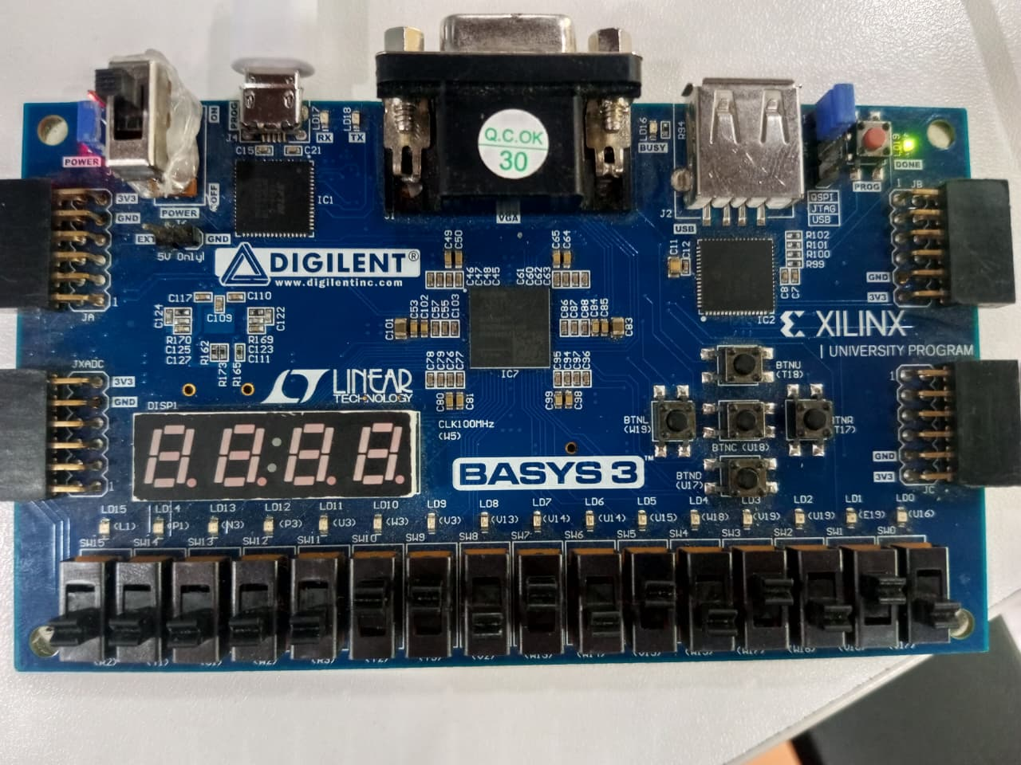

Write data holds value when write enable is off. And switches are even changed

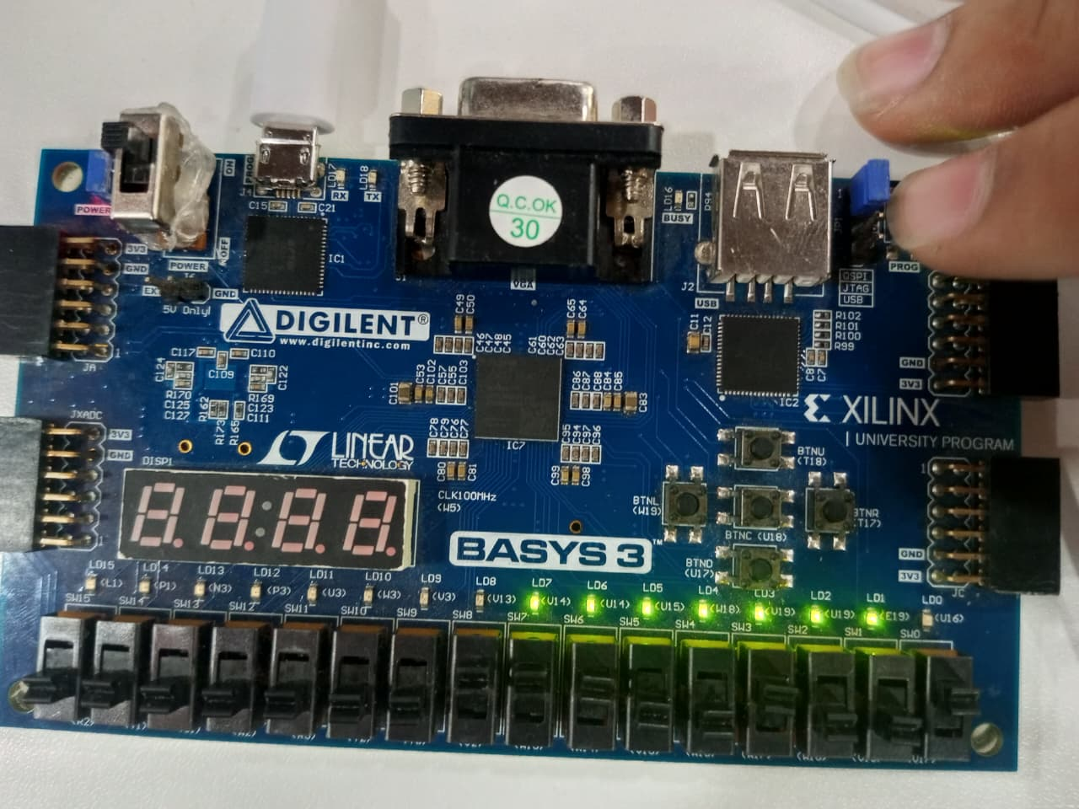

All LEDs will be OFF when:

Reset; press btnC anytime
SW11=DOWN: writeEnable off, nothing gets written
SW8=DOWN, SW9=DOWN, SW11=UP: memory region, LEDWrite never asserts
SW8=DOWN, SW9=UP, SW11=UP: switch region, LEDWrite never asserts
SW8=UP, SW9=UP, SW11=UP: invalid region 11, no device selected
SW8=UP, SW9=DOWN, SW11=UP, SW0-SW7=all DOWN: correct region but writing 0x00 to LEDs
Power on before any switch touched: register initializes to 0

Assessment Rubric
Lab 8: Design and FPGA Implementation of Memory System with Address Decoding for a Single-Cycle RISC-V Processor

Name: | Student ID: | Section:

Points Distribution

 | Task No. | LR 2 (Code) | LR 5 (Results) | LR 11  (Design)
In-Lab | Task 1 | - | - | /20
In-Lab | Task 2 | /20 | /15 | -
In-Lab | Task 3 | /10 | /15 | -
Total Points |  | /30 | /30 | /20
CLO Mapped |  | CLO 1

Affective Domain Rubric |  | Points | CLO Mapped
AR7 | Report Submission & Git Upload | /10 & /10 | CLO 1

CLO | Total Points | Points Obtained
1 | 100
Total | 100

For description of different levels of the mapped rubrics, please refer to the Lab Evaluation Assessment Rubrics and Affective Domain Assessment Rubrics provided here.

